University of Rajshahi

Rajshahi 6205, Bangladesh

Prepared By,

Sujan Kumar Roy

Lecturer, Dept. of CSE, RU

**CSE4142**

**Lab Manual**



**Computer Peripherals**

**& Interfacing Lab**

**Department of Computer Science & Engineering**

**University of Rajshahi**

**Assignment1**

**Title:** Design and implement an 8-bit input port to interface with 8085 microprocessor.

**Outline:** This assignment is a simple representation of input port design for 8085 microprocessor. More specifically, it simply interfaces an 8 bit DIP switch with 8085 microprocessor. The 8085 MP should capable of reading 8 bit data from that input port.

**Task:** In order to design the required circuit, it requires the following ICs.

* + - 74LS138
    - 74LS244
    - 8085 MP
    - Etc.

The following circuit is an example of an input port having address FDH.

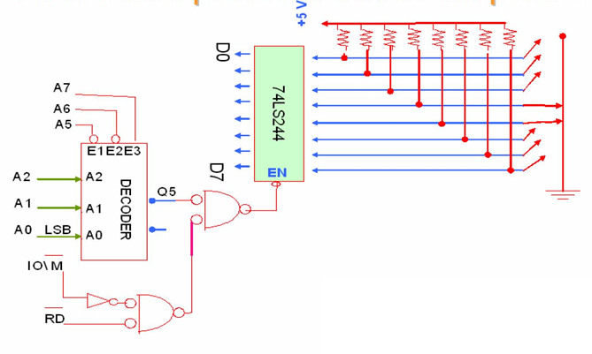

**Figure 1: An input port of 8085 MP with address FDH.**

**Testing:** For testing the designated input port, write a simple program that read 8-bit input from DIP switches and add the data with other 8-bit data of register B. Finally display the output to the LED of microprocessor trainer.

**Report Writing:** For report writing instructions, just follow the following instructions:

* Name of the Experiment
* Objectives
* Apparatus
* Design & Implementation
* Results & Discussions
* Precautions

**Mode of Evaluation:** Presentation, Implementation & Testing, and Viva.

**Percentage of Weight:** 70%.

**Assignment2**

**Title:** Design and implement an 8-bit output port to interface with 8085 microprocessor.

**Outline:** This assignment is a simple representation of output port design for 8085 microprocessor. More specifically, it simply interfaces an 8 bit LED with 8085 microprocessor as an output port. The 8085 MP should capable of displaying 8 bit data to output port.

**Task:** In order to design the circuit, it requires the following ICs.

* + - 74LS138
    - 74LS373
    - 8085 MP
    - Etc.

The following circuit is an example of an output port having address FBH.

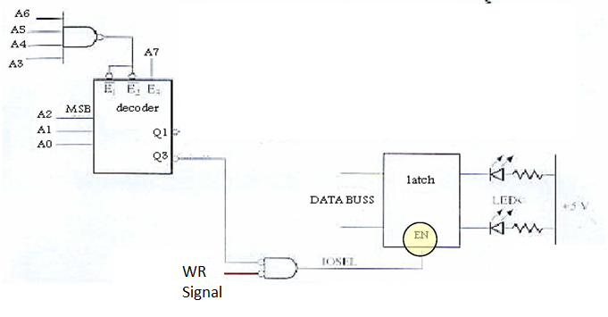

**Figure 2: An output port of 8085 MP with address FBH.**

**Testing:** For testing the designated output port:

(i) Write an assembly language program to calculate the summation value of the following series and then display the summation value to the LED.

1+2+3+ - - - - - + n, here, n is a positive integer number.

(ii) Write an assembly language program to calculate the factorial value of a positive integer number and then display the factorial value to the LED.

**Report Writing:** For report writing instructions, just follow the following instructions:

* Name of the Experiment
* Objectives
* Apparatus
* Design & Implementation
* Results & Discussions
* Precautions

**Mode of Evaluation:** Presentation, Implementation & Testing, and Viva.

**Percentage of Weight:** 70%.

**Assignment3**

**Title:** Design and implement a ZERO-TO-NINE (MODULO TEN)* COUNTER controlled by 8085 MP.

**Outline:** This assignment is a simple representation of a BCD counter interfaces an 8 bit LED with 8085 microprocessor to display each count.

**Task:** In order to design the circuit, it requires the following ICs.

* + - 74LS138
    - 74LS373
    - 8085 MP
    - Etc.

For circuit designing, just follow the circuit diagram of Figure 2.

**Testing:** For testing the designated counter:

Write a program that can count 0 to 9 with a one second delay between each count. At the count of 9, the counter should rest itself to 0 and restart counts. Also display each count to a designated output port. The flowchart and program are as follows:

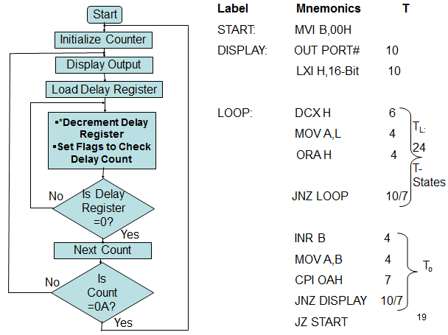

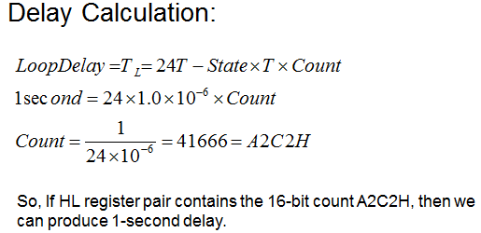

**Report Writing:** For report writing instructions, just follow the following instructions:

* Name of the Experiment
* Objectives
* Apparatus
* Design & Implementation
* Results & Discussions
* Precautions

**Mode of Evaluation:** Presentation, Implementation & Testing, and Viva.

**Percentage of Weight:** 100%.

**Assignment4**

**Title:** Design and implement a traffic signal controller and interface with 8085 MP.

**Outline:** This assignment is a simple representation of a traffic signal controller with five signs, RED, GREEN, YELLOW, WALK, and DON’T WALK.

**Task:** Write a program to provide the given on/off time to three traffic lights (Green, Yellow, and Red) and two pedestrian signs (WALK and DON’T WALK). The signal and signs are turned on/off by the data of an output port as shown below:

|  |  |  |
| --- | --- | --- |
| Lights | Data Bits | On Time |
| 1.Green | D0 | 15 seconds |
| 2.Yellow | D2 | 5 seconds |
| 3.Red | D4 | 20 seconds |
| 4.WALK | D6 | 15 seconds |
| 5.DON’T WALK | D7 | 25 seconds |

The traffic and the pedestrian flow are in the same direction; the pedestrian should cross the road when the Green light is on. Also write a delay subroutine that provides at least one second delay between each on/off.

|  |  |  |  |  |  |  |  |  |  |  |
| --- | --- | --- | --- | --- | --- | --- | --- | --- | --- | --- |
| Time Sequence in Seconds | | DON’T WALK | WALK |  | Red |  | Yellow |  | Green | Hex Code |
| (15)  (5)  (20) | 0 | D7 | D6 | D5 | D4 | D3 | D2 | D1 | D0 |  |
| 15 | 0 | 1 | 0 | 0 | 0 | 0 | 0 | 1 | 41H |
| 20 | 1 | 0 | 0 | 0 | 0 | 1 | 0 | 0 | 84H |
| 40 | 1 | 0 | 0 | 1 | 0 | 0 | 0 | 0 | 90H |

**The flowchart is as follows:**

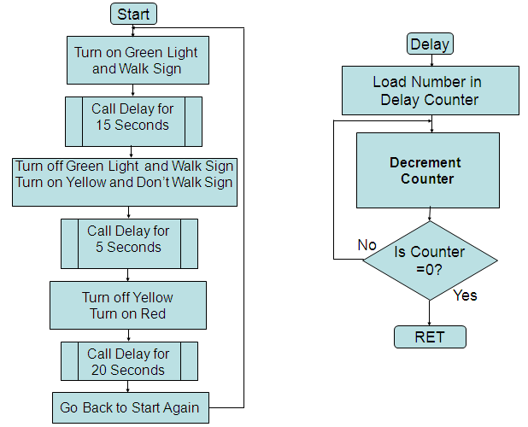

In order to display the output, just follow the circuit diagram of Figure 2.

**Report Writing:** For report writing instructions, just follow the following instructions:

* Name of the Experiment
* Objectives
* Apparatus
* Design & Implementation
* Results & Discussions
* Precautions

**Mode of Evaluation:** Presentation, Implementation & Testing, and Viva.

**Percentage of Weight:** 100%.

**Assignment5**

**Title:** Interface an 8 bit D/A converter with 8085 microprocessor.

**Outline:** This assignment is a simple interfacing technique for 8 bit D/A converter with 8085 MP. To do this, design an output port with address FFH interface 1408 D/A converter with 8085 MP and calibrated from 0 to 10V.

**Task:** In order to design the circuit, it requires the following ICs.

* + - 74LS138
    - 74LS373
    - 1408 D/A converter.
    - 8085 MP
    - Etc.

For circuit designing, just follow the circuit diagram of Figure 3 as below.

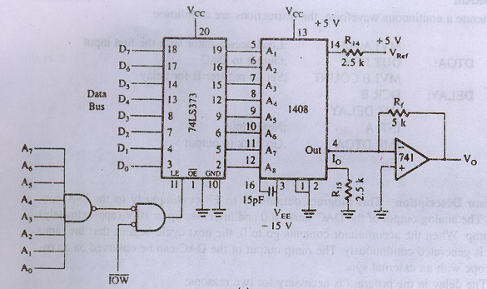

**Report Writing:** For report writing instructions, just follow the following instructions:

* Name of the Experiment
* Objectives
* Apparatus
* Design & Implementation
* Results & Discussions
* Precautions

**Mode of Evaluation:** Presentation, Implementation & Testing, and Viva.

**Percentage of Weight:** 100%.